For the beginning in order to test if there is and what is wrong with your ASCU, we will ask you to do the following:
This version of ASCU has a test mode.
1. To enter in this mode you must take the ASCU out of the gearbox.
2. Then connect the both boards to each other and then connect the motor. (hold the motor tight in hand to prevent jumping on rotation).
3. Now connect the battery. You have about 2-3 seconds in which time you have to push the lever of the cut-off sensor once.
If you do this properly (and cut-off sensor works), you must hear a 3 long beeps.
Now ASCU is in test mode and you can test it's components:
- push cut-off sensor: will hear beep while holding; (no beep means that sensor is not working)
- On the back of the ECU board you will find the two fire-selector switches, hold the upper switch and press the trigger switch on the Mosfet Board, the motor will start for a second an then stop. (no motor spinning means that trigger switch or selector switch is not working) After this you must push cut-off sensor again if you want to test fire again.
- Hold both selector switches on back of the ECU board and press the trigger switch on the Mosfet Board, the motor will start and stop 2 times. (no motor spinning means that trigger switch or selector switch is not working). After this you must push cut-off sensor again if you want to test fire again.
- connect terminals of hop-up sensor connector with some kind of conductor and you have to hear a beep while holding; (no beep means that sensor is not working)
To exit of test mode just disconnect battery.
Please do the test and let us know the result. After that we will take care to solve the problem ASAP

Recently we have found out that on some AEG models the Gearbox shells are more narrow from inside, and this results in over tightening the ASCU and blocking the Cut-Off sensor. Check the attached picture and cut the marked notches. Please let us know if that has solved the problem.
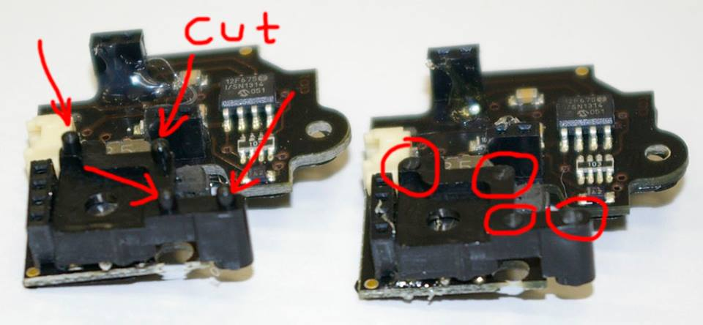
info@airsoftsystems.com

